PSHE Policy
(Including Relationship, Health and Sex Education)

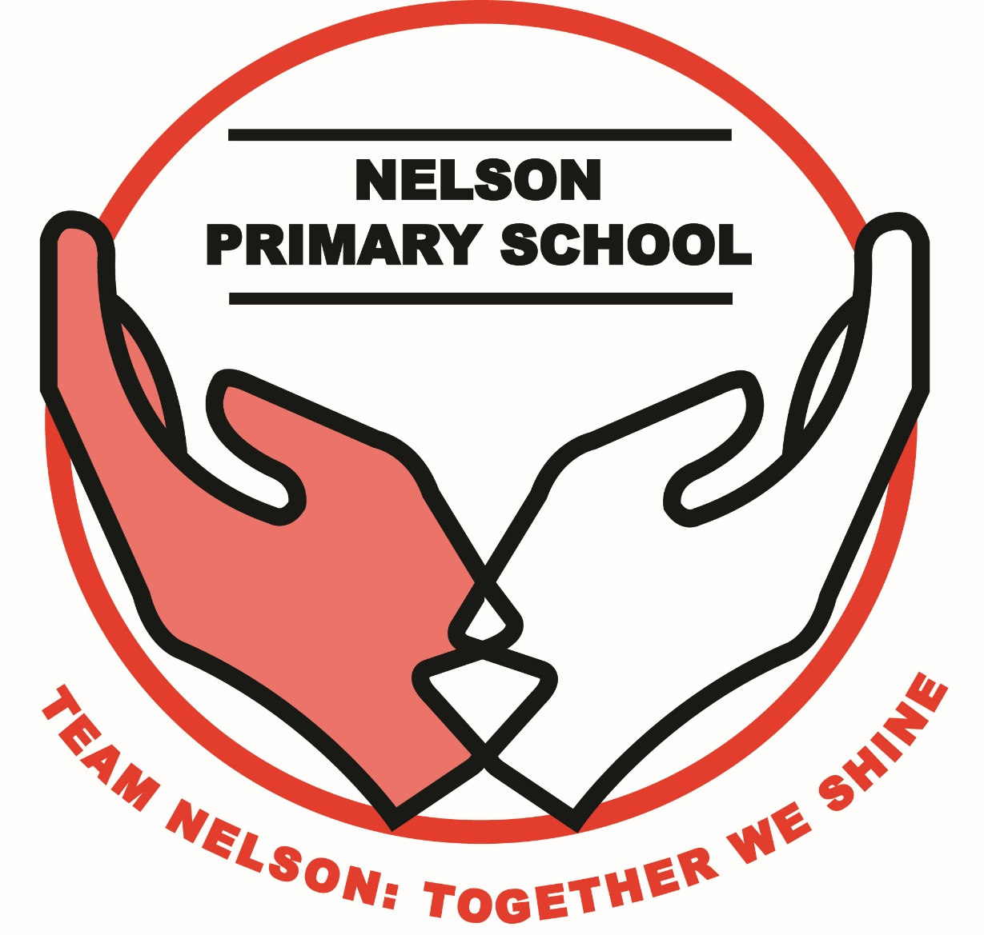

Responsibility: Piers Hargreaves
Approved on: 17th July 2025
Next Review Date: July 2027

School Vision and Rationale

Much thought has gone into the curriculum intent for Nelson; we have asked ourselves what is most important to enable our pupils to have successful, happy lives and contribute positively to society.
The intent of the PSHE curriculum is to create responsible, active citizens who know how to keep themselves safe and have the skills to build positive relationships with others.

Most of Nelson pupils live in the local area: Ladywood. This area has, for a long time, been known for its high levels of deprivation, child poverty and crime. The very nature of living in Ladywood means that Nelson pupils are likely to face significantly more challenges than most children, finding themselves in situations where they have to make tough choices, often having to consider what is the ‘right’ thing to do in very difficult circumstances. Adding to this is the rapidly changing world we now live in and the difficulties this creates which pupils need to be able to adapt and respond to. Our school curriculum intent is to educate and empower our pupils to be able to make good decisions which protect them and the world around them. We understand that high academic grades alone are not enough for our pupils, as living in poverty can mean that they will have to have the determination and willpower to remain focused on their education and not be tempted into anti-social behaviour or law breaking.

The PSHE scheme of work is devised to ensure pupils have the knowledge they will need to keep themselves safe in this local and global environment, while preparing them for a future in which they can have positive, healthy relationships. Content is not static, but changes regularly to reflect the current needs of our pupils and the wider community. Lessons include the creation a safe space where pupils can openly share their ideas and consider alternatives. Pupils are taught debating skills so they are able to confidently articulate their thoughts and challenge those who oppose them or beliefs which do not reflect British Values.

All subjects at Nelson aim to encourage the skill of considering the value of something or the consequences of particular decisions or actions, and this includes PSHE. ‘Dilemma based learning’ is included and pupils are expected to use ‘active compassion’ to situations they are presented with. This teaches them that sometimes difficult choices need to be made in life and so it is important for consequences to be carefully thought through before acting.

The PSHE curriculum aims to teach pupils the vital knowledge they need to keep themselves safe, including the correct language to use so that their thoughts and feelings are clearly communicated. This includes tackling sometimes uncomfortable topics, such as FGM and islamophobia. It also makes links to Children’s Rights, as well as challenging stereotypes in discussions around topics such as: gender equality, disability and racism; enabling our pupils to learn about what unites them, rather than allowing differences to divide them.

To embrace the challenges of creating a happy and successful adult life, pupils need knowledge that will enable them to make informed decisions about their wellbeing, health and relationships and to build their self-efficacy. Our pupils can put this knowledge into practice as they develop the capacity to make sound decisions when facing risks, challenges and complex contexts.
Everyone faces difficult situations in their lives and this area of our curriculum can support our pupils to develop resilience, to know how and when to ask for help, and to know where to access support.

High quality, evidence-based and age appropriate teaching of these subjects can help prepare pupils for the opportunities, responsibilities and experiences of adult life. This can also help schools to promote the spiritual, moral, social, cultural, mental and physical development of pupils both at school and in society.

Relationships and Health Education (RHE) is a fundamental part of our Personal, Social, Health and Economic Education (PSHE) curriculum for pupils in our school. It is embedded in our PSHE curriculum and our aim is to equip children with the skills and understanding to become healthy, secure, independent and responsible members of society.

Through all aspects of the RHE curriculum we promote spiritual, moral, social and cultural education, whilst considering the mental and physical development of pupils at school.

We prepare our pupils for the opportunities, responsibilities and experiences in later life and encourage them to use developing social skills and knowledge to identify risk to make safe decisions for them.
RHE has an integral part to play in building pupils’ mental wellbeing and their understanding of themselves as part of a family, community and wider society. As our pupils grow, they will understand their rights as global citizens and the responsibility that this brings.

From September 2020 it is a legal requirement to teach Relationships and Health Education at primary school and parents do not have a legal right to withdraw their child(ren) from teaching on these subjects.

In addition to the requirements of the National Curriculum in Science, the school teaches Sex Education. This comprises of a lesson in Year 5 which identifies the male and female reproductive systems and a lesson in Year 6, which teaches how babies are conceived. Parents will be notified in writing before these lessons take place so that they can notify the school that they would like to withdraw their child from these specific lessons.

School Context

Our school community comes from a wide and diverse society. A proportion of pupils are eligible for the pupil premium funding and this is used to provide additional support for those pupils for their wellbeing and academic achievements. For example, our Learning Mentor delivers a variety of small group and 1-1 programmes with pupils on areas such as resilience, social skills and bereavement.

Policy Development and Consultation

The policy has been developed through consultation with our school’s stakeholders, which include parents, governors, staff and pupils and has paid due regard to the Public Sector Equality Duty and issues relating to National Health Targets, and safeguarding of pupils including Child Sexual Exploitation, Female Genital Mutilation and Homophobia.
Relationships and Health Education
At Nelson Primary School, understanding the way in which relationships develop and grow over time from childhood through to adult relationships is part of lifelong learning. Part of this is about the understanding the importance of relationships and the values, qualities and responsibilities
in friendships, families, and loving relationships and how to develop an understanding of safety in the online environment. It promotes self-respect, confidence, respect & responsibility toward others, emphasising the importance of marriage, loving relationships, safety, love and care.

Health Education includes the teaching of puberty and the changes that occur as pupils move into adolescence. The lessons will be based on teaching children facts in an age appropriate way to support children to flourish and grow.

Aims and Objectives of this policy and the PSHE curriculum:

- To provide clear guidance for parents, staff and governors in relation to programme progression and delivery
- For pupils to develop the understanding of relationships and that they need to be built and maintained gradually
- Relationship Education provides a foundation for further work at secondary school
- To help young people to respect themselves and others
- To support pupils through their physical, emotional and moral development
- To develop skills and understanding to enable pupils to make healthy, responsible choices about their health and well-being including personal hygiene
- To help pupils understand the significance of marriage and stable relationships and its importance for family life *Care needs to be taken to ensure that there is no stigmatisation of children based on their home circumstances*
- To help pupils move more confidently and responsibly into and through adolescence
- To help pupils to understand a range of views and beliefs about relationships
- To help pupils to understand issues of media influence and mixed messages that may contradict and conflict with own beliefs
- Know and understand what constitutes a healthy lifestyle;
- Be aware of safety issues;
- Have respect for others regardless of race, gender, mental and physical disability, and sexual orientation;
- Be independent and responsible members of the school community;
- Be positive and active members of a democratic society;
- Play an active part in decision making;

Resources

- All staff have received unit plans for each year group. The scheme of work is reviewed yearly;
- All staff use R-Time materials to deliver R-Time sessions weekly
- All staff use Peer Massage materials to deliver Peer Massage sessions daily;
- All staff have access to a large bank of additional resources to support the delivery of PSHE;
- The Christopher Winter Project schemes of work are used to teach drugs and alcohol lessons, and ‘Clued up for Growing Up’ is used to teach puberty lessons;
- Other resources are selected from respected providers, such as the PSHE Association, Women’s Aid, Barnardo’s, Educate Against Hate, thinkyouknow and Since 911.

* Parents are able to request to view the materials at any point throughout the year.

Assessment, Recording and Reporting

- Teachers assess the children’s learning by making informal judgements as they observe them during lessons;
- Teachers or pupils record each week in a PSHE evidence book;
- Pupils who demonstrate either a high or low understanding of the topics will be recorded. The PSHE Leader will use this information to inform our safeguarding provision for vulnerable pupils.
- A comment relating to PSHE will be included in the annual report to parents on pupils’ progress.

Moral and Value Framework

The programme will reflect the school’s Diamond Rules:

- Show respect and god manners
- Care for everyone and everything
- Follow instructions with thought and care.

Content of Programme

Our PSHE curriculum (which includes Relationship and Health Education) has been developed through progressive units beginning from Reception to Year 6. (Please refer to the Long Term Plan)

Organisation and Methods of Teaching

- This scheme of work has been planned by school staff and supporting external agencies
- The programme will be taught by class teachers with supporting staff to ensure that both pupils and staff are protected
- The discrete puberty and ‘Clued Up for Growing Up’ lessons in Years 4, 5 and 6 will be taught in selected single sex groups
- Pupils will be taught about the changes related to their own and the opposite sex, how to manage the changes and where to get help at home and school
- Girls will be made aware of who can provide support, where menstruation provision is kept and where the appropriate disposal bins are situated. They will also be taught about FGM and how this contradicts the rights of child.
- Content will include topics particularly relevant to our pupils, such as: Islamophobia, railway and canal safety, gender equality, CCE, knife crime, forced marriage, loan sharks and modern day slavery.

Areas of Responsibility

Head Teacher and Governors:
- Ensure the framework is followed
- Ensure that this policy is made available to parents
- When developing and amending this policy, work with parents and listen to their views

Teaching Staff:
- Implement this policy with the guidance of senior leaders in the school
- Ensure that the policy is followed in applied practice
- Liaise with the governors on the teaching of RHE and Sex Education in school as required
- Liaise with parents and feedback any concerns, following the school’s usual procedures
- Respond to the needs of pupils, following the school’s usual procedures

Specific Issues

Confidentiality
Pupils will be informed that as with any other safeguarding issue, confidentiality cannot always be assured and the school will follow the usual procedures for keeping children safe and protected from harm (please refer to school’s safeguarding procedures).

Use of External Providers
External providers should be made aware of the school’s policies and procedures prior to planned delivery. They will be expected to follow the school’s agreed scheme of work and that all delivery with pupils will be evaluated.

Answering Difficult Questions
If a pupil/student asks a difficult question during a whole class session, staff will be expected to answer honestly and factually
Pupils’ questions will be answered according to their level of maturity and understanding, with support from parents
The programme will be designed to focus on boys as much as girls and activities will be planned to ensure both are actively involved, matching their different learning styles
Teachers will focus heavily on the importance of healthy relationships
Responses to questions answered need to follow the school’s policy. Any concerns raised should be discussed with a senior leader or DSL, depending on the concern

Working with Parents

The school has established a strong working partnership with parents through consultation and support. The school recognises that parents are key educators and maintain a vital role in
providing education about relationships and growing up, and therefore aims to support parents in this role.
On an annual basis parents will be specifically informed about the discrete lessons on sex education and provided with the opportunity to view resources and discuss the teaching content before any delivery takes place.
Details of other specific lessons and teaching materials can be made available on request. Parents can raise questions on this policy in writing, by phone or by making an appointment with Miss Forrest.

Parent Withdrawal
Parents have a right to withdraw their child from sex education lesson(s) but not from Relationships and Health Education lessons.

Where a pupil is withdrawn from sex education, the class teacher will ensure that the pupil receives alternative appropriate education, which may include the child working on an alternative project.

Any complaints will be addressed through the school’s complaints procedure

Provision for Menstruation

Miss Bi (Learning Mentor) will be available to support pupils and will have all the necessary
resources. Sanitary disposal units are situated in the UKS2 girls’ toilets.

Equal Opportunities / Inclusivity

The school’s PSHE programme will reflect the ethos of the school, by providing a secure, non-judgmental environment in which to learn, in accordance with any protected characteristics as defined by the Equality Act 2010.

Monitoring and Evaluation

This policy will be managed by the PSHE Leader and an appointed governor will be responsible to ensure that the programme is evaluated and impact reported to the governing board.

The policy will be reviewed annually by the Safeguarding Committee

Dissemination of the Policy

This policy will appear in the school website. Parents will be supplied with a fully copy on request.

This policy should be read in conjunction with:
‘Relationships Education, Relationships and Sex Education (RSE) and Health Education; Department for Education statutory guidance for governing bodies, proprietors, head teachers, principals, senior leadership teams and teachers.’

Other related documents & policies
- Education Act 2002
- Keeping Children Safe in Education 2023
- Working Together to Safeguard Children
- Equality Act 2010
- Science Curriculum KS1 & KS2
- Children and Social Work Act 2017
- Relationships Education, Relationships and Sex Education and Health Education (England) Regulations 2019
- OFSTED School Inspection Handbook
- Relationship & Health Education Statutory Guidance 2019 (DfE)
- United Nations Convention on the Rights of the Child

