Attendance Policy



Responsibility: Mr Hargreaves
Approved on: April 2025
Next Review: April 2026


Nelson School
Attendance and Punctuality Policy

Our aim at Nelson School is to provide the greatest opportunity for children’s learning. We endeavour to provide all our pupils with an equal chance to make the most of the education that school offers, for this to be achieved, it is vital that every child attend school regularly and punctually. Good attendance is everyone’s responsibility.

Parents have a legal responsibility to ensure their children attend school regularly. However, the school recognises that problems may occasionally occur which affect this. Through working in partnership with parents, we can find solutions to problems and ensure children’s right to a full education.

Aims

At Nelson School we aim to:
- Create a positive, welcoming environment so children are motivated to attend school.
- Develop supportive strategies to encourage good attendance and punctuality;
- Ensure pupils, parents and staff understand of the importance of regular school attendance and punctuality;
- Ensure all staff understand their role and responsibilities regarding attendance.
- Sets targets for attendance annually and submit data to the DfE;
- Use attendance data to identify/address any trends of individuals or groups;
- Reduce unauthorised absence/leave of absence through the framework provided by Birmingham City Council (Support first, Leave of Absence legal process, Penalty Notices and Prosecution);
- Recognise and celebrate regular/improved attendance and punctuality;
- Take steps to provide learning for pupils unable to attend school due to serious health issues (and support their return to school).

Roles and responsibilities

Every member of staff has a responsibility in securing good attendance for all pupils. The table below shows the staff member responsible for monitoring and action planning at each attendance band.

Attendance percentage | Responsible staff member
98% - 100% | Class Teacher
96% - 97% | Pastoral staff
Below 96% | Attendance Leader
Below 90% (Persistent absence level) | Attendance Leader
Below 50% | Attendance Leader/ DSL/SENDCo./CASS (Multi agency approach)

Procedures for dealing with absences.

- On the first day of absence, parents are expected to call the absence line and provide a reason for absence. If no contact is made, a phone call is made to children’s parents and a record of the outcome is recorded on the SIMS system.
- If the first day contact phone call has been unsuccessful in establishing a reason for absence, then a phone call will be made to the emergency contact.
- If absence continues with no reason, on the third day a home visit will take place to check the welfare of the child. If contact cannot be made, a letter will be posted requesting contact to be made immediately with the school. Failure to return to school within 5 days of absence will result in a letter requesting the expected date of return with consideration of school place. A referral is then made to Children Missing Education team and the absence is reported.
- Where a teacher/office staff is not satisfied with the reason given for a particular absence or period of persistent absence, the child’s name and details are referred to the Attendance Leader, who will pursue the matter.
- Pupils identified as at risk of persistent absence (15 to 18 days absent) will be contacted by the Attendance Leader to attend an informal meeting to discuss patterns or absence and to see if early help and/or a referral to the school nurse is needed for an unmet health need as well as to agree an attendance action plan to prevent the pupil becoming a persistently absence. (19 days absent)
- Appendix 1 attached shows the flow chart for manging absence, Appendix 2 shows the procedure for a child missing education and Appendix 3 shows the support first process.

Personalised Pupil Progress Tracking Sheets

During pupil progress meetings, attendance issues that are impacting on progress are discussed and recorded in the space provided. These concerns are communicated to the Attendance Leader, who discusses this with the parents. These concerns may also be raised during parents evening by the class teacher.

What do we define as being late?

If a child arrives at school after 9.00am the child is considered late and will be given a late mark ‘L’. The time registers are ‘closed’ officially is 9.30am. If a child arrives after this time, they will be given a ‘U’ (late after register closes) mark.

Procedures for dealing with lateness

- School doors are closed at 8.50am. Registers open at 9.00am after this time, children are classed as arriving ‘late’ and must report to the office, where names are recorded and the appropriate code added to the class electronic register on SIMS. Children may be required to ‘make-up’ lost learning time due to lateness depending on the circumstances.
- Class teachers will address issues of lateness where a child has arrived more than three times late within a half term during parent meeting.
- The attendance team monitors punctuality on a regular basis. Where lateness persists letters will be sent and meetings held as appropriate. The impact of letters/meetings is evaluated over time and action plans put in place where necessary.
- Persistent lateness will be dealt with by the Attendance Leader and the head teacher in liaison with the Local Authority.

Medical Appointments
Parents are actively discouraged from arranging routine medical appointments during the school day as dentist and GP’s surgeries are open outside of school hours. Parents need to inform the office in advance of any medical appointments and show the appointment letter/card. If children arrive late during the morning due to a medical appointment, the register code ‘M’ will be used as long as appropriate evidence has been provided.

Registration

Registration takes place at the beginning of the morning and afternoon sessions. This is completed using the electronic CMIS system and is the class teacher’s responsibility. An ‘N’ is used for absence and the office/attendance team updates these following first day phone calls.

If a class are on a day trip, the register must be completed for both the morning and afternoon sessions by the class teacher before they depart. The afternoon session should not be completed for those children that are not going on the trip. (A list of all children on trips is left with the office by the class teacher.)

Please note that registers must be completed accurately for safety reasons such as in the event of a fire and because they constitute a legal document and form part of a chain of evidence.

A class teacher concerned about the accuracy of their register should contact the office for advice.

On a Friday afternoon the office makes a record of the class attendance figures. This is used for the weekly KS1 and KS2 attendance recognition assemblies and the attendance data shared with parents via the headteachers newsletter.

Class teachers receive a weekly attendance record (by the Senior Office Manager) for their class the previous week. This information is used to update the attendance display. Class teachers have the responsibility for checking the attendance record and ensuring it is an accurate document.

Raising Attendance Concerns

Staff
Attendance is on the weekly agenda of phase group meetings, so staff can raise concerns and identify any patterns of poor attendance that they may have noticed. Any concerns will be passed on to the Senior Attendance Champion.

Parents
Should parents find themselves in a position where they feel there may be barriers to their children attending school regularly, they should seek the support of the attendance team so school can find ways to ensure attendance is not affected.

The Attendance File

This is kept by the attendance leader and contains information on whole school, class and individual pupils along with analyses of trends over time and across the school. Records are also kept of the outcomes of meetings with parents.

Role of the Senior Attendance Champion

Children are required to attend school 190 days every year. Whilst the ethos of Nelson is that attendance is everyone’s responsibility it is the legal responsibility of the parents/person/people with parental responsibility to ensure they do. Attendance and punctuality are closely monitored and when it is appropriate for school to take action this will be undertaken, and feedback given to class teachers. Parents who fail to fulfil their responsibility will be prosecuted.

Nelson works with the Local Authority to address poor attendance through the support first process. Persistent unauthorised absence is not tolerated. As part of the leave of absence legal process, parents may be issued with a notice to improve, penalty notices and could face prosecution. The Senior Attendance Champion is responsible for gathering evidence/communicating with parents who are part of this process and regarding any court proceedings.

Leave of Absence

The Education (Pupil Registration – England) Regulations 2013 and the Education (Penalty Notices – England) Regulation 2013 are now in force and followed by this school. The law clearly states that parents have legal duty to ensure child/children attend school regularly and that head teachers can only authorise leave during term time in exceptional circumstances, which must be evidenced.

Taking unauthorised leave in term time is therefore grounds for issuing a penalty notice (Starting at £80 per parent, per child). All parents are informed of this when children join the school, reminders are sent out termly and details appear on the school website, in the Headteacher’s newsletter and in the safeguarding newsletter. This is in line with the policies in all other local schools.

Parents requesting leave of absence will be referred to the Attendance Champion or Office Manager, who will explain the procedures in person. Parents must then complete a leave of absence request form which is submitted to the head teacher. The outcome of the request will clearly state if the leave is authorised or unauthorised and the consequences. This will be posted to parents. If travelling abroad, the Attendance Champion will request copies of travel documentation and parents will be informed that if the children do not return on the stated dates, they will be reported as missing.

Nelson does not authorise leave in term time unless there are exceptional circumstances.

If the pupil is female and from a Female Genital Mutilation (FGM) practicing or affected community, then the Headteacher or DSL will use direct questioning to ascertain whether “cutting” of the girl will be undertaken during this holiday. The Headteacher will then take the information from this meeting and make a decision on whether to refer to Children’s Services (3031888) or the Police (101).

Children who are absent from school must not be present in public places. Penalty notices may be issued where parents allow their child to be present in a public place during school hours without reasonable justification.

Rewards and Incentives

- Displays show attendance figures relative to the rest of the school.
- Attendance data for each class is sent out weekly so parents are aware of how their child’s class is doing.
- Parents of the pupils in the class with the highest attendance each term are awarded a shopping voucher.
- Classes who achieve 95% attendance and above each week earn points towards rewards such as additional playtime.
- Attendance certificates are awarded during special assemblies each term for pupils who have 95% and above attendance.

Rewards and incentives are reviewed with the pupils and may change based on pupil feedback as partners in driving good attendance.

Monitoring and Evaluation

The systems and policy are monitored and reviewed at least annually. The attendance and punctuality data is analysed by the attendance team weekly. At the beginning of each half term, the leader reviews the attendance of any child below 96% with the Head teacher.
Factors are recorded that may affect overall school attendance e.g. extended absences, religious festivals, pupil mobility etc. Pupil records are transferred and received in line with legal requirements.

Notes:
The term ‘parent’ refers to:
- Any natural parent to the child/children whether married or not
- Anyone who has parental responsibility for that child/children
- Anyone who cares for/has responsibility for looking after that child/children

Appendix 1
Attendance flowchart

Child is marked absent on the class register

9.30am previous days are checked to see if there is an obvious or previously notified reason for absence.

From 10.00am if there is no contact from parents, phone calls are made to parents’ contact numbers to ascertain reason for absence.

If there is still no contact, any siblings in school are asked if they know the reason for absence.

If, after three days, there is still no contact from parents, home visits will take place from SLT / Attendance Officer.

If no contact is made during home visits, a letter must be posted and DSLs notified to consider any Child Protection Concerns.

Absent From Education Procedures to be followed if pupils are absent for 5 days.

Appendix 2
Child Absent from Education procedure

NO CONTRACT AGREED BETWEEN SCHOOL AND PARENTS
- Register absence as unauthorised using the code ‘G’

SCHOOL UNABLE TO CONFIRM WHEREABOUTS OF PUPIL or DISCOVERS PUPIL IS ALLEGEDLY ON LEAVE
- Send Letter Four (Appendix 6) to home address
- Make ‘reasonable enquiry’ (Section 9.9) (including a home visit by a home school link worker, learning mentor or other)
- Head Teacher informed of outcome of visit

PUPIL RETURNS TO SCHOOL WITHIN FOUR WEEKS
- Consult EWS re possible penalty notice
- Invite parents into school for a formal meeting re; impact on pupil attainment and progress, and set target for attendance improvement
PUPIL HAS NOT RETURNED TO SCHOOL AFTER 5 SCHOOL DAYS
- School to refer to CAfE team

PUPIL HAS NOT RETURNED TO SCHOOL AFTER 20 SCHOOL DAYS OF UA
- Send letter to home address
- Wait for contact from parents/ take advice from the CAfE team regarding removal from roll.
- Complete Admission/Withdrawal form

Appendix 3 Support first guide
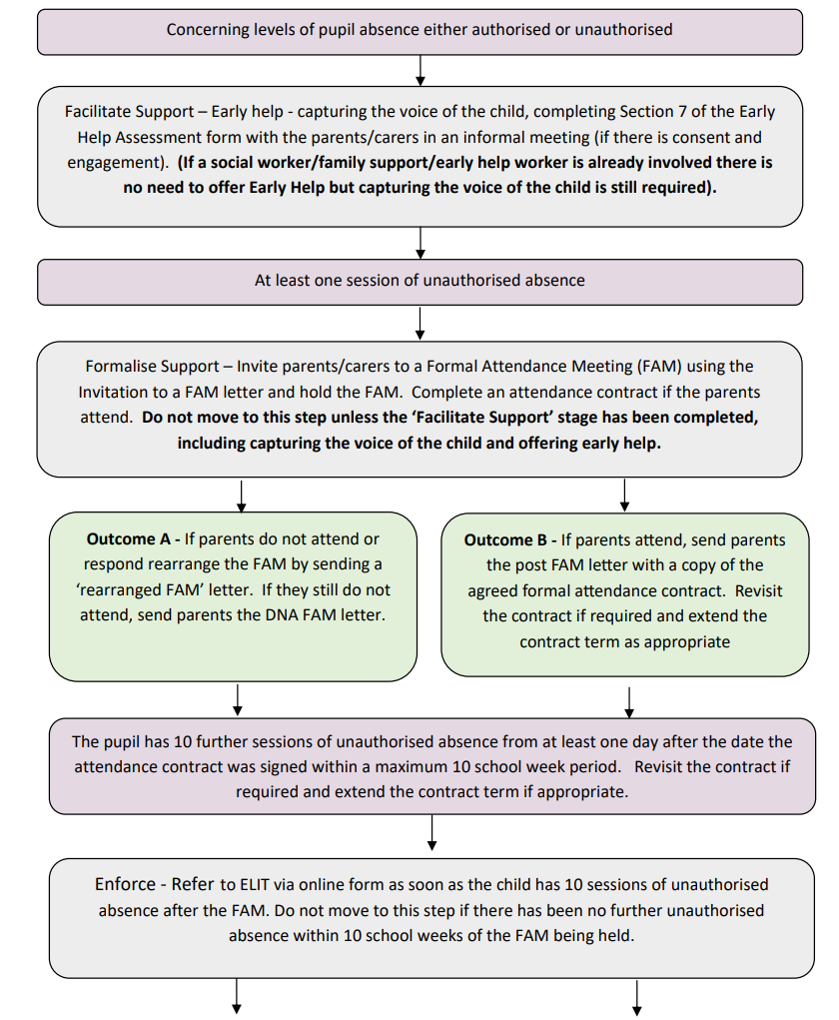

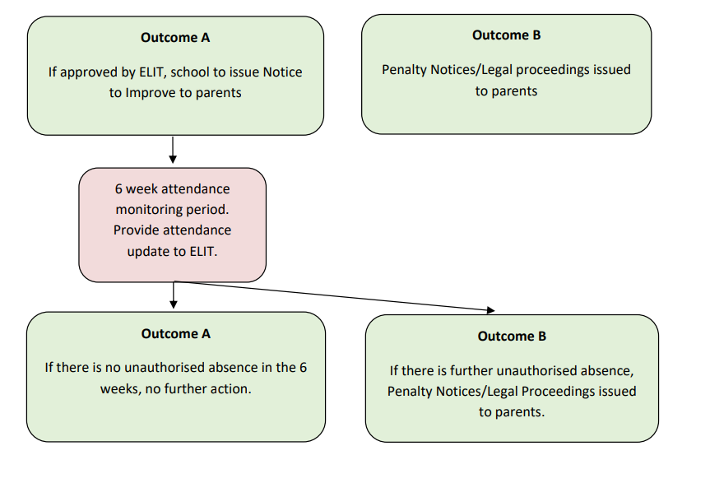

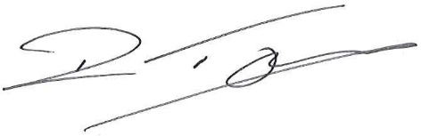
Daniel Taylor, 9th April 2025

