Nelson’s Safeguarding Newsletter
Spring term 2026


WHO TO CONTACT IF YOU HAVE A CONCERN ABOUT A CHILD

If you are worried about a child's safety, please do not hesitate to contact any of the Designated Safeguarding Leads straight away.
The following members of staff are Designated Safeguarding Leads for Nelson Primary School:
- Miss Barnes (DSL)
- Miss Forrest
- Mr Hargreaves
- Miss Bi
They can be contacted via the school office, or by telephone on 0121 464 2201.
You can also contact CASS (Children’s Advice and Support Services):
0121 303 1888
If a child is in immediate danger, call the Police immediately on 999.
Dear Parents and Carers,
Welcome to our Spring term safeguarding newsletter. This edition covers places you can go to report harmful online content and road safety.
If you come across any useful safeguarding resources or information that you think the school community would benefit from seeing, please let us know via the school office.
Miss Barnes
Designated Safeguarding Lead

The impact of too much screen time
Many children love using tablets, phones and computers, but too much screen time can affect their wellbeing. Spending long periods on screens can make it harder for children to get good sleep, stay active and focus during the day. They may also come across things online that are not suitable for their age. Setting simple, consistent boundaries—like having screen-free mealtimes, keeping devices out of bedrooms at night, and talking regularly about what they’re doing online—can help children enjoy technology safely while still having plenty of time to play, relax and connect with others.

Attendance
Regular school attendance is essential for children’s learning, confidence and wellbeing. When children attend every day, they build strong routines, stay connected with friends and teachers, and make steady progress in all areas of the curriculum. Even small amounts of missed learning can add up over time, making it harder for children to keep up and feel settled in school. By ensuring your child comes to school every day—unless they are genuinely unwell—you are giving them the best possible chance to succeed and enjoy their education.

Attendance for this term

93%

Road Safety
As the weather improves and we begin spending more time outside, it’s important to remind children about staying safe on and around roads. With families out and about more often, teaching children to stop, look and listen before crossing, to use designated crossings, and to stay close to a trusted adult is essential. Practising these simple habits together helps keep everyone safe. By encouraging children to stay alert and avoid distractions like phones or scooters near roads, we can help ensure they enjoy a safe and happy holiday break.

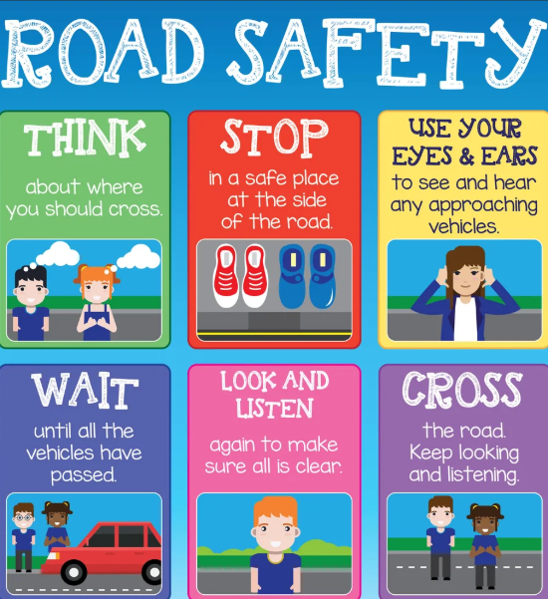

Reporting harmful content

It is important that harmful content is reported so that it can be addressed by appropriate bodies and make the internet a safer place. If your child comes across harmful content when online you can use these websites to report that content.

Report Harmful Content - UK Safer Internet Centre You can use this website to find out where to report harmful content.

Harmful online content: how to report it and where to get help This website has links to places to report different types of harmful content.



